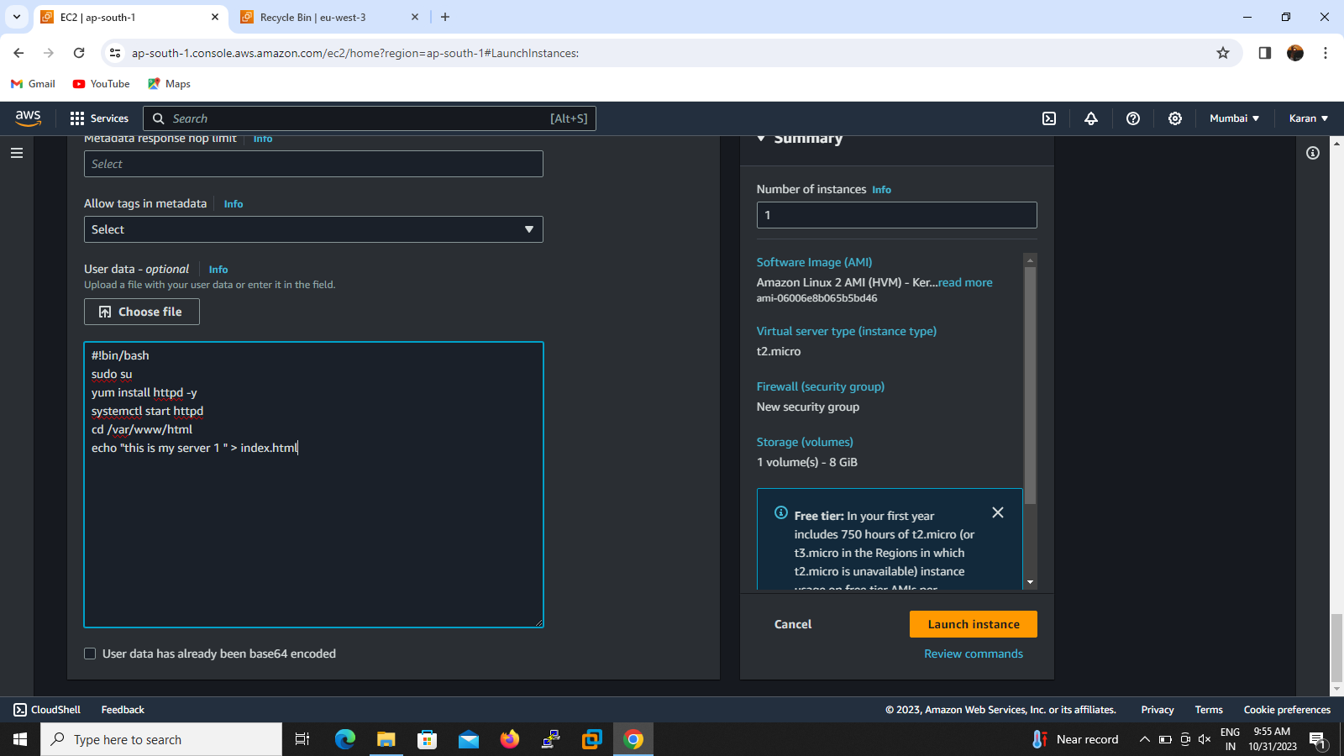

To spreadup the load to each server from the DNS , I creating two instance with content in /var/www/html/index.html .Temprorily I written inside the file this is my server 1 for 1st instance and this is server 2 for 2nd instance and it launced successfully .then will go the load balancer tag and create classic load balancer fill the all details like ,load balancer name,selecting instance,and configuration setting then create .here load balancer DNS name show copy and paste to brower result will be come .see the screenshot for better understanding.

